- \Operation\Tube filling\Dosing\Tube filling – dosing component A - timing
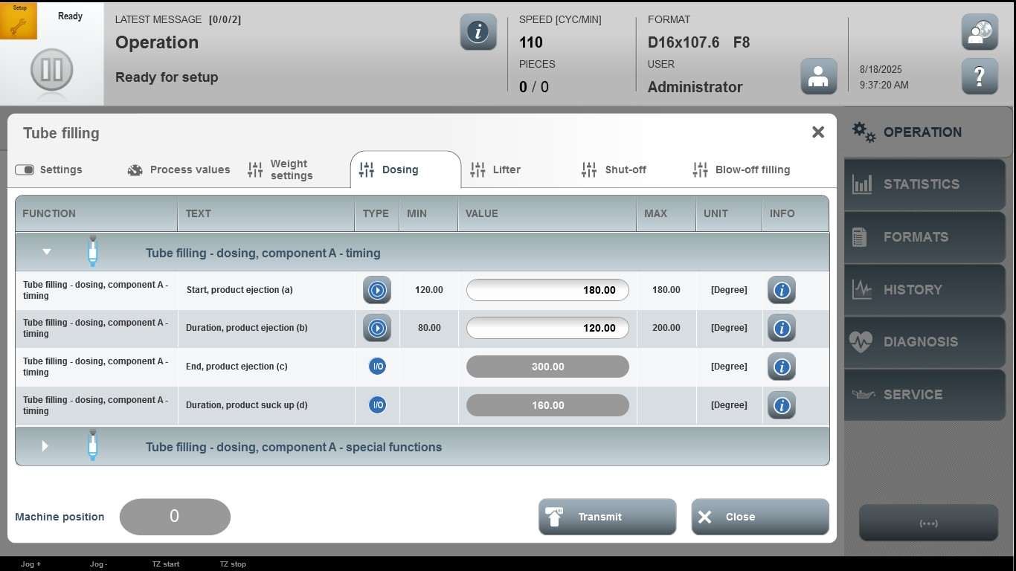

Acceptance criterion | Limits | Pass / Fail: Dev-No. | Date | Initials
Screen matches screenshot | N / A
Start, product ejection (a) | 120.00…180.00
Duration, product ejection (b) | 80.00…200.00

